* **Name of the Activity:** One Day Workshop on Introduction of NCC course as an elective subject in UG Level
* **Date of the Activity:** 28.07.2022
* **Speaker:** Col. Hemant Jha, Officer of the Indian Armed Force.
* **Organizing Department:** Seminar Sub-Committee, Chakdaha College and University of Kalyani
* **Number of Participants:** 20
* **Outcome:** The inclusion of National Cadet Corps (NCC) training could become an integral component of the undergraduate curriculum. According to the expert perspective presented by Colonel Jha, the emphasis was placed on the advantages of integrating NCC training into the curriculum and its potential outcomes as a structured course activity.
* **Photographs of the Workshop:**

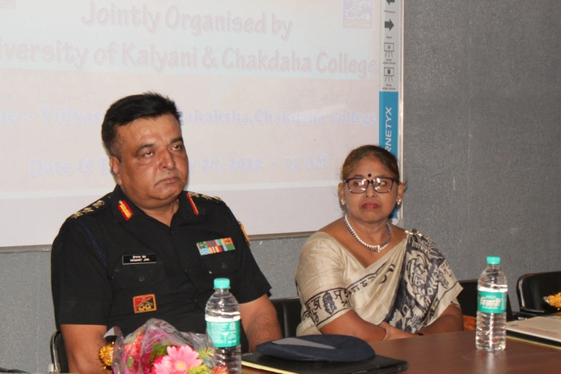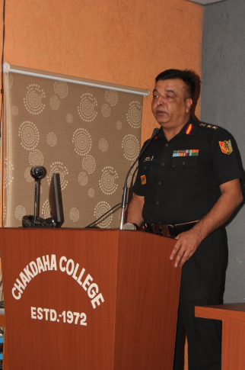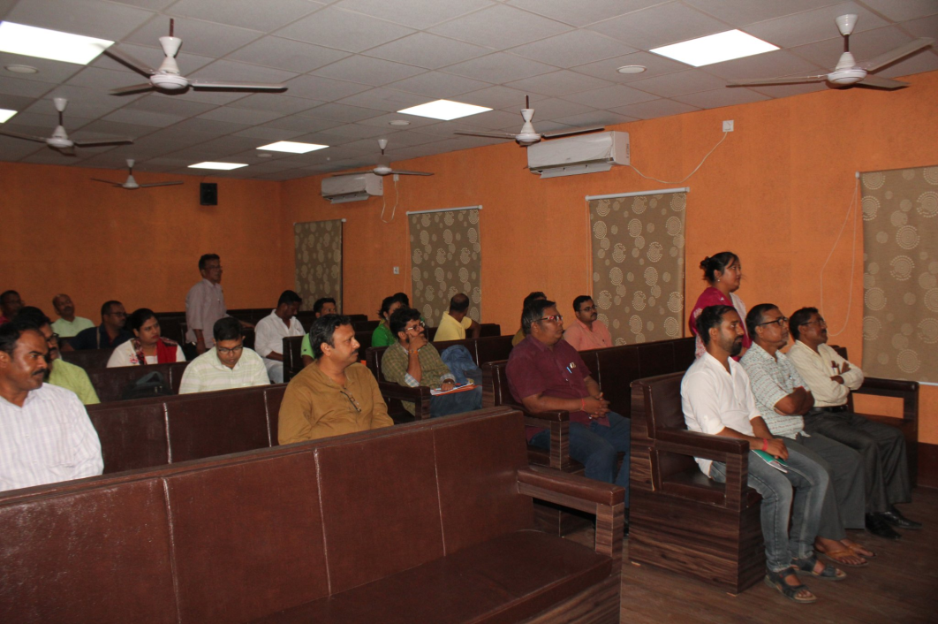

Attendance:

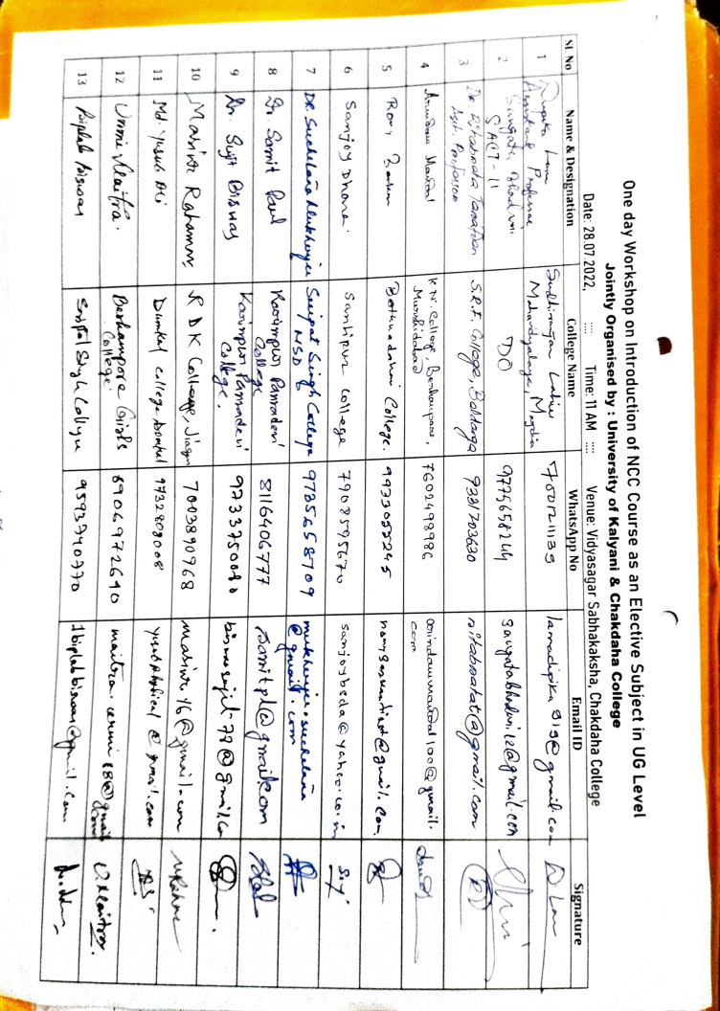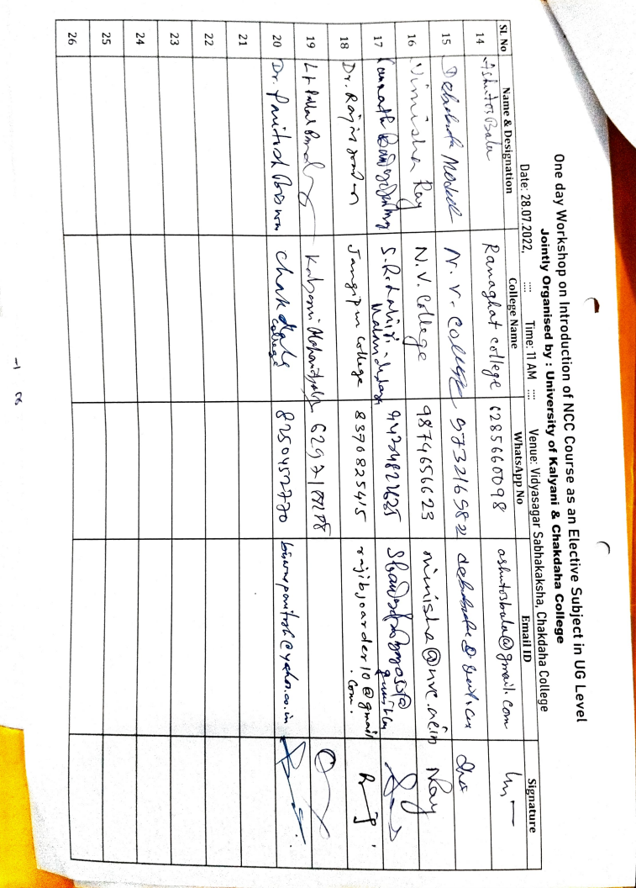

***Relevant Web Link:***

[https://www.facebook.com/photo/?fbid=563711705489463&set=pcb.563713842155916](https://www.facebook.com/photo/?fbid=563711705489463&set=pcb.563713842155916%20%20)